**Bio and Details- Sammya Brata Mullick**

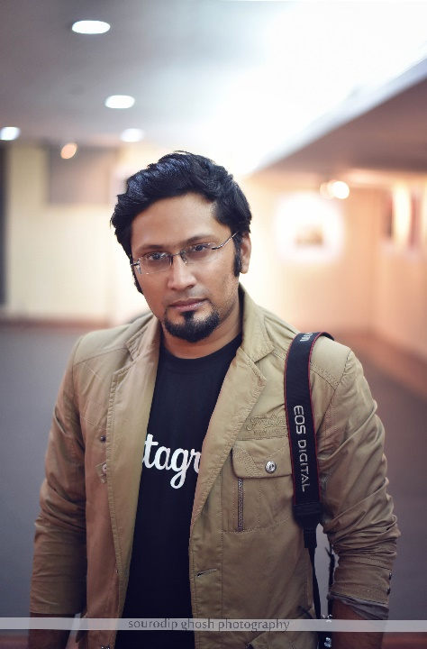

**Short Bio**- *A consultant by profession, Sammya Brata is the founder of Calcutta’s very first and the largest Instagram community “Calcutta Instagrammers”. Sammya Brata, who is also a popular Photo-blogger, is also regarded as one of the key social media influencers and has worked in social media campaigns for renowned brands for their nation-wide trending campaigns. He has also won numerous PAN India blogging competitions conducted by renowned brands like Kotak Mahindra, Star Sports, Sky Scanner, Bacardi, Magma India, ASUS, Borosil, Bluestone, WeChat, Vicks etc. He has won international trips on account of his blogging endeavors including covering the very prestigious “One Republic Concert” in Malaysia. He has also been invited to reputed institutes across the country as a key speaker on Photography and social media. He has also been the curator for large scale mixed media exhibitions including the Calcutta Art Confluence and Pickle Factory India.*